Type Three Tranny Mount for the GBE® Five-speed
By Toby Erkson, July 1998

Guidelines for installing the transmission mount for the late model Type III. This operation should be done with at least two people.
1. Jack up rear end and remove rear tires.
2. Remove the engine and tranny and stock nose cone tranny mount. The stock nose cone mount will not be reused.
3. Put the new tranny on the engine and test fit the assembly in vehicle. Note where nose cone meets the torsion housing. Grind the right side of the torsion housing down, a little bit at a time, and test fit the assembly until there is no metal-to-metal contact. Grinding just a little bit from the lower edge of the tranny housing is okay to help the fit and keep from rubbing too much on the torsion housing and gives just a little more space between everything.
4. Once everything looks good polish and clean the metal for the upcoming welding work.
5. Weld up the holes in the U-bracket (frame-to-nose tranny mount) and redrill them so they are 100mm apart, measured from center to center. Note: This should be fabricated by GBE® as part of the Type III tranny mount kit for consistency and accuracy.
6. Stuff a rag down and forward into the shift tunnel from the shift coupler. Carefully remove the shift coupler. The rag helps to keep any parts from rolling forward into the shift tunnel where they would be extremely difficult to remove.
7. Access to the shift coupler is complicated by the fact that the set screw hole is on top of the hockey stick (shift selector) instead of the proper Type III position of the bottom. There are two ways to attack this problem, as described below, short of drilling a new hole:
7a. Cut the opening in the sheet metal where the hockey stick passes through to the shift tunnel. The opening should be at least 7cm wide. This allows the coupler, attached to the hockey stick, to easily pass through the hole when you reinstall the tranny. This is the better method.
7b. The other option is to drill a hole in the top of the shift tunnel as follows (Image 7):
Inside the car, under the rear seat, will be two bolts that are about 20cm apart (measuring from their centers) located on the outer top edge of the tunnel near the rear seat back. Measuring from the center of the right bolt (i.e. passenger side) go 9.5cm towards the center of the tunnel. From that point move rearward 3.5cm. Drill a 1” diameter hole at this point. This allows access to the coupling securing screw. Drilling will be difficult since you will be drilling through two layers of chassis steel. Be sure to treat the exposed metal, like with primer, when done to keep rust from forming.
8. Securely bolt the U-bracket to the frame in place of the stock mount and firmly bolt the tranny mount to the tranny. You will need to put the 37.5mm collars over the mounting bolts. This will provide the proper spacing between the U-bracket and the frame (Image 2). A washer may be needed between the collar and the U-bracket if additional spacing is required.
Note: The frame horns that are required should be fabricated by GBE® and included as part of the tranny mount kit (Images 8 and 9). We used channel shaped over other shapes (90°, tube and boxed) for a couple of reasons. It’s structurally strong enough not to deform like angle iron may and allows more access to the reverse light switch unlike boxed or tube horns.
9. Install the tranny and engine assembly into the vehicle. Loosely bolt the engine into its mounts and the tranny mount to the U-bracket mount. Make sure everything is lined up nice and straight!
10. Bolt the vertical rubber mounts on the top part of the tranny mounts. Place the frame horns on the torsion housing so the rubber mounts just touch the frame horns. Place the ends of the frame horns that will be welded to the torsion housing about 29cm inside of the trailing arm. Mark the frame horn’s location or place a couple of tack welds to hold them to the torsion housing (difficult to do, limited space!). See Images 5 and 6.
11. Remove the engine and tranny assembly and weld the frame horns in place. The outside edge of the channel of the frame horns will be around 14 ¾” distant. Be sure you have them positioned correctly, in fact, tact weld them in place and test fit the assembly again to make sure everything is lined up. The extra time spent will keep major disappointment away!
12. Once the frame horns are completely welded in let things cool down then treat the metal to keep rust from occurring. I used Corroless® rust conversion paint then sprayed that with flat black paint.
13. Attach and wire lock the shift coupler to the hockey stick on the tranny. You may need to drill the setscrew hole open a little deeper and wider.
14. After the paint dries installation can continue as normal. Don’t forget to remove the rag from the shift tunnel once the shift coupler has been reattached to the shift rod. I secured the breather hose to the lower left shock mount, pointing down.

Addendum:
Please note that measurements were approximated for my Type III. Where like components have differing measurements an average of the two would probably suffice for reproduction purposes. Naturally a slightly longer frame horn is more desirable than one that’s slightly short as excess metal can be removed more easily. This is a great time to replace the coupler, check the entire CV assemblies, clean the engine compartment and engine and check/tidy-up wires since every thing will be out of the way!

Permission granted to Gene Berg Enterprises® for purposes of reproduction and use, in part or in whole.

DISCLAIMER: THE MATERIALS ARE PROVIDED "AS IS" WITHOUT ANY EXPRESS OR IMPLIED WARRANTY OF ANY KIND INCLUDING WARRANTIES OF MERCHANTABILITY, NONINFRINGEMENT OF INTELLECTUAL PROPERTY, OR FITNESS FOR ANY PARTICULAR PURPOSE. IN NO EVENT SHALL THE AUTHOR BE LIABLE FOR ANY DAMAGES WHATSOEVER (INCLUDING, WITHOUT LIMITATION, DAMAGES FOR LOSS OF PROFITS, BUSINESS INTERRUPTION, LOSS OF INFORMATION) ARISING OUT OF THE USE OF OR INABILITY TO USE THE MATERIALS, EVEN IF THE AUTHOR HAS BEEN ADVISED OF THE POSSIBILITY OF SUCH DAMAGES. BECAUSE SOME JURISDICTIONS PROHIBIT THE EXCLUSION OR LIMITATION OF LIABILITY FOR CONSEQUENTIAL OR INCIDENTAL
DAMAGES, THE ABOVE LIMITATION MAY NOT APPLY TO YOU. The author does not warrant the accuracy or completeness of the information, text, graphics or other items contained within these materials. The author may make changes to these materials, or to the products described therein, at any time without notice. The author makes no commitment to update the Materials.

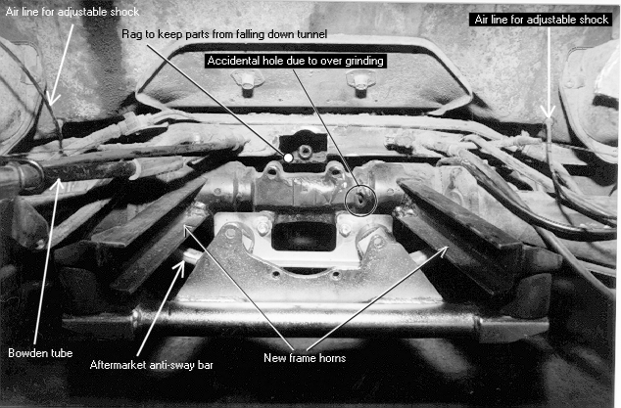
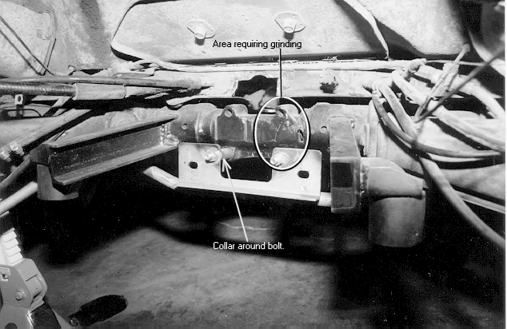
Image 1

Explanation of items
Image 2

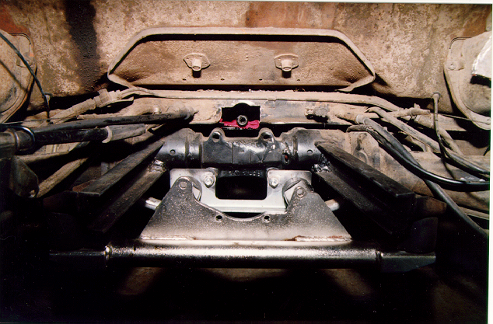

Image 3

Color images
Image 4
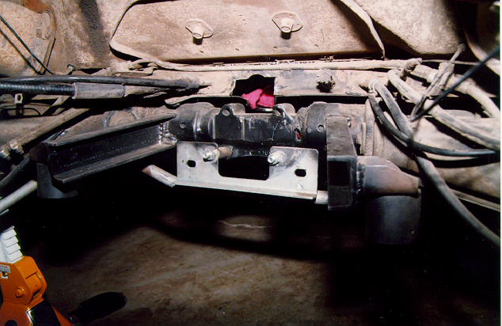

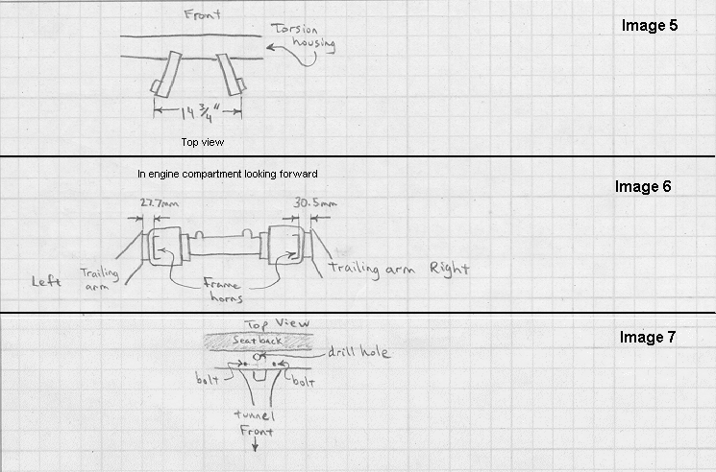

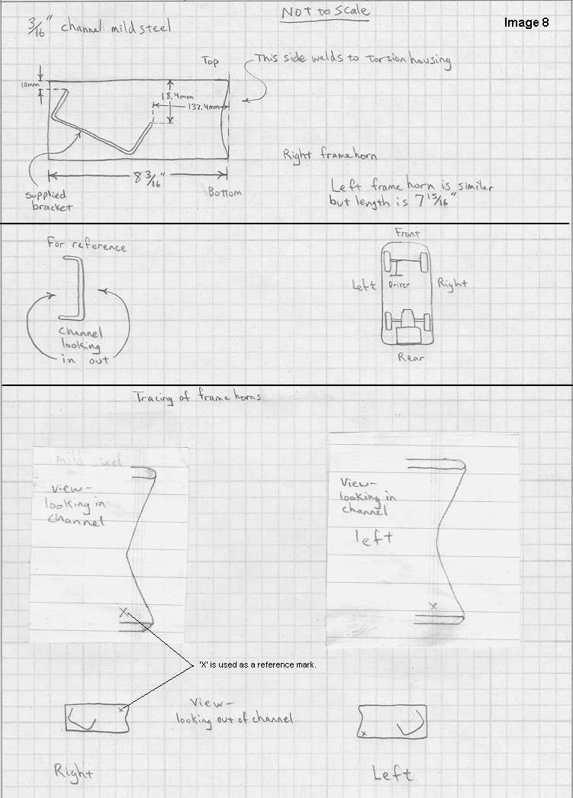
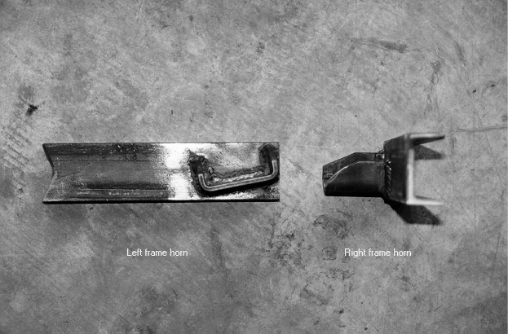
Image 9

